Magnetometer Hardware Description
Clayton Gumbrell
23 December 2008
Hardware Version X

Description

PCB Layout
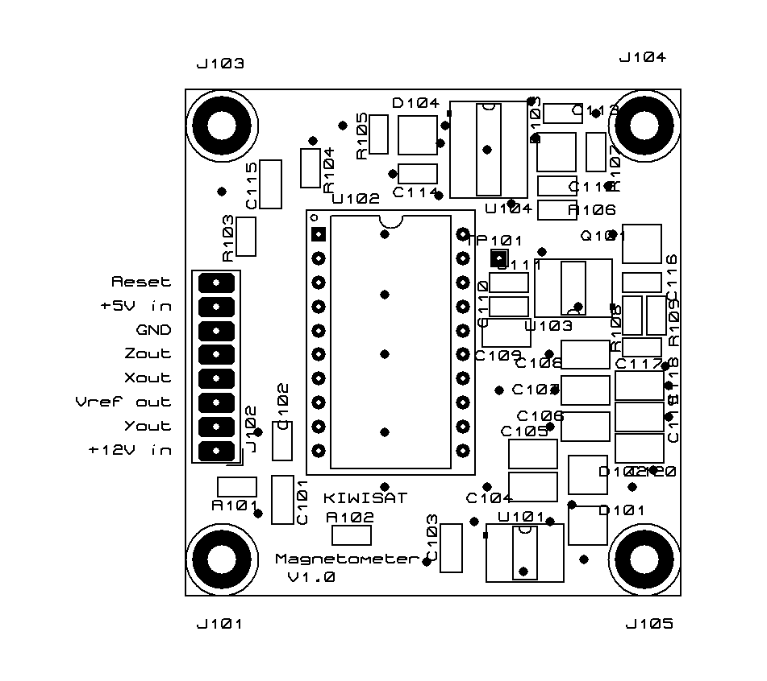

PCB Connections
J102 is the power, signal and outputs connections
Connections | Signal | Description
J102 – 1 | +12V in | +12V supply in
J102 – 2 | Y out | Y channel output. 1.5 – 3.5V
J102 – 3 | Vref out | Reference voltage output (2.5V)
J102 – 4 | X out | X channel output. 1.5 – 3.5V
J102 – 5 | Z out | Z channel output. 1.5 – 3.5V
J102 – 6 | GND | Ground (0V)
J102 – 7 | +5V in | +5V supply in
J102 – 8 | Reset | Reset pulse. Idle state = high. Pulse low for a few 100 uSec to reset the sensor, thus clearing any residue magnetism.

